**DAILY ONLINE ACTIVITIES SUMMARY**

|  |  |  |  |  |  |  |  |  |
| --- | --- | --- | --- | --- | --- | --- | --- | --- |
| **Date:** | **29-05-2020** | | | | | **Name:** | **Rohan Mahaveer** | |
| **Sem & Sec** | **6th B** | | | | | **USN:** | **4AL17CS077** | |
| **Online Test Summary** | | | | | | | | |
| **Subject** | | **OR** | | | | | | |
| **Max. Marks** | | **30** | | **Score** | | | **30** | |
| **Certification Course Summary** | | | | | | | | |
| **Course** | **Cyber security-zero to hero in 9 hrs** | | | | | | | |
| **Certificate Provider** | | | **Udemy** | | **Duration** | | | **9 hrs** |
| **Coding Challenges** | | | | | | | | |
| Problem Statement: 1. Write a java program to balance bracket.  2. write a python to find digital root of a number | | | | | | | | |
| **Status:** YES, Completed all Programs | | | | | | | | |
| **Uploaded the report in Github** | | | | | **YES** | | | |
| **If yes Repository name** | | | | | <https://github.com/rohanmahaveer/daily-status> | | | |
| **Uploaded the report in slack** | | | | | **YES** | | | |

Online Test Details:

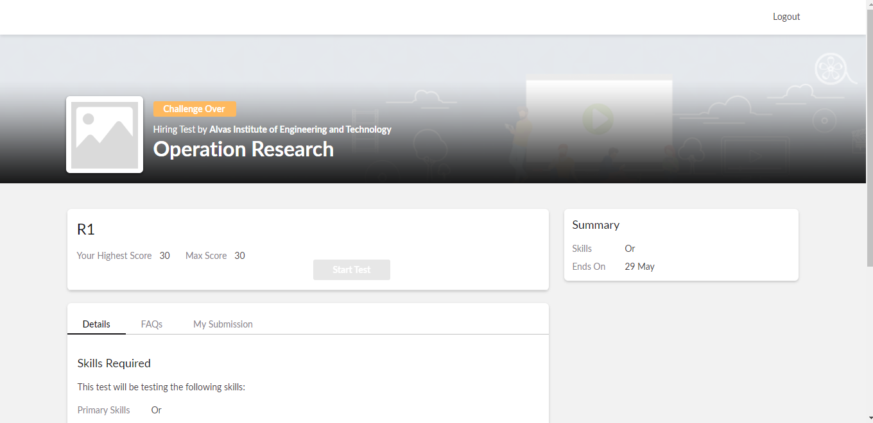

Scored 30 out of 30 in OR 2nd I.A test

Certification Course Details:

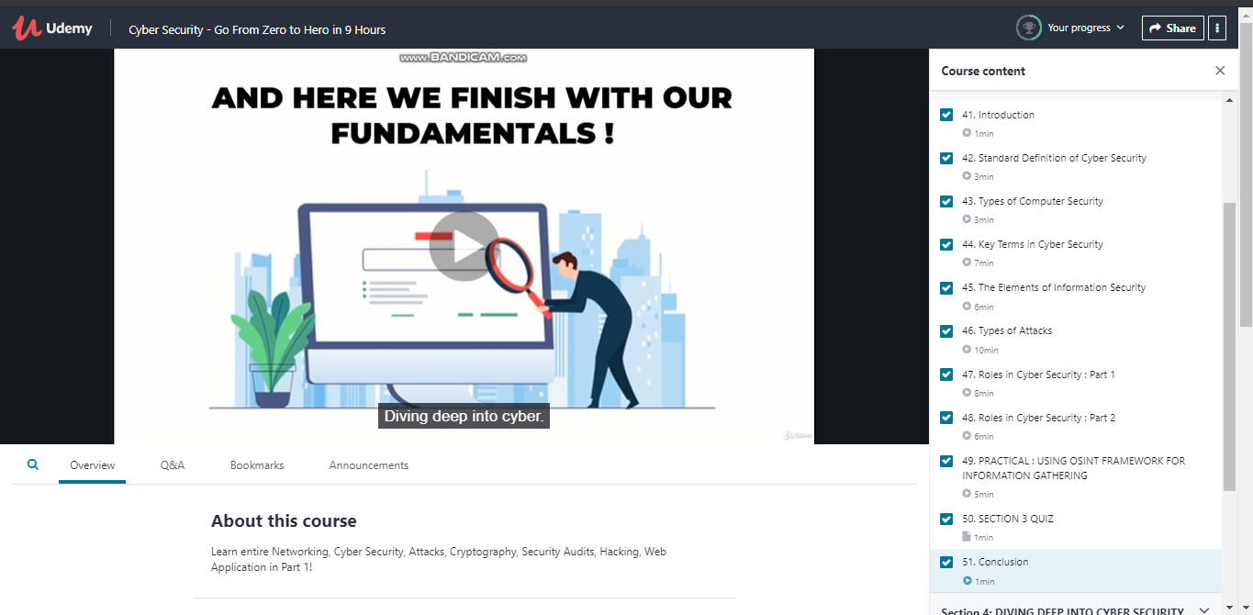

The above course is being taken up by me is based on cyber security. Today in online course I studied about the key terms in cyber security and different roles in cyber security. The details of the course and certificate provider are mentioned in the above form.

Coding Challenges Details:

Program1:

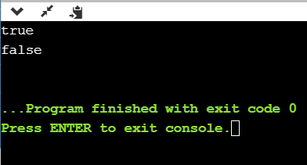

Program2:

